BOTTLED ELEPHANTS

You will need:

- 3 litre or 1 litre milk or juice bottle - cleaned and dried
- Texta that will draw on plastic
- Scissors
- Stanley knife
- Craft glue
- Paint brush and old plastic container
- Extra milk bottle lids or soft drink lids for eyes
- Things to cover and decorate you elephant can include:
- Cut or torn up coloured paper, magazines, glitter, silver foil, stickers, felt, fabric- anything!

How to make your elephant:

Step 1 - Making the legs and trunk shape
Pics 1-4:
- Find the ridge that goes around the milk bottle just below the bottom of the label.
- From this line draw arches on the sides and front and back. Have a look at the pictures.
- The bottom of the milk bottle stays as a base for your elephant.
- The front will be where the handle is. The front arch needs to go up behind the bottom of the handle.

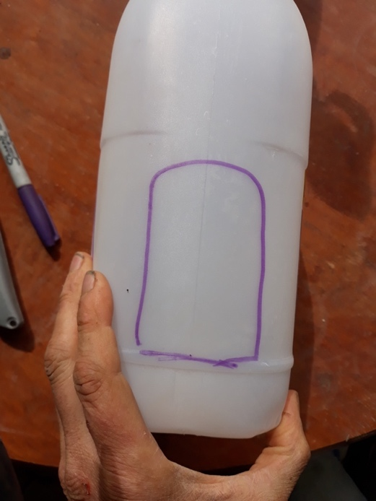
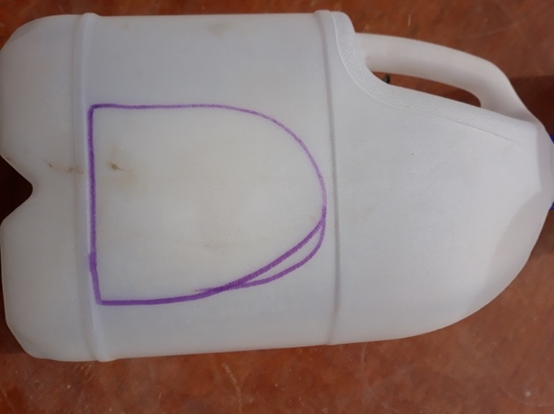

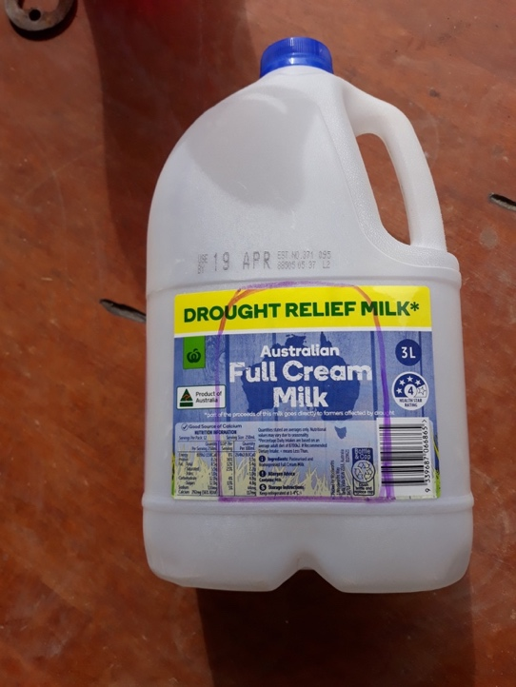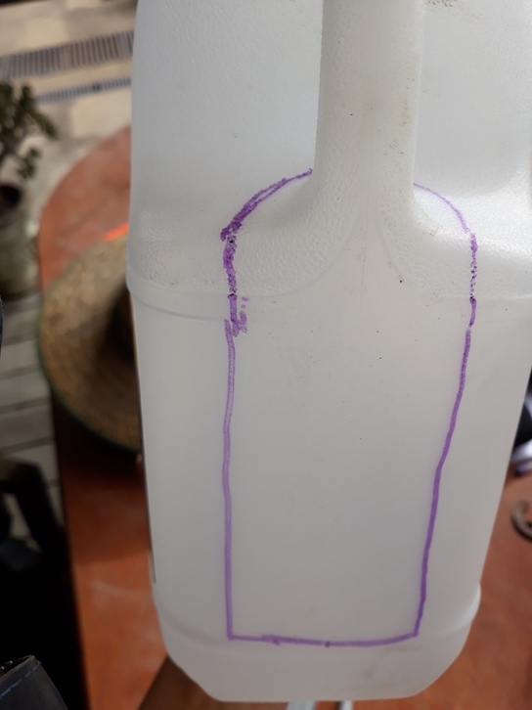

Step 2 – Cutting the shapes out
Pics 5 - 8
Carefully using a Stanley-knife cutting away from you, cut out the arches in the sides and back.
For the front; cut through the bottom of the handle first. Cut carefully just above and around the handle for the front arch.
You will have created four legs and a trunk!

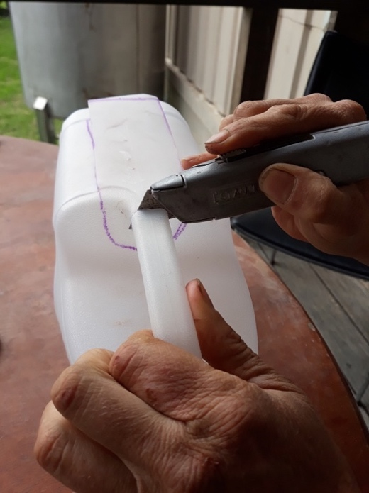
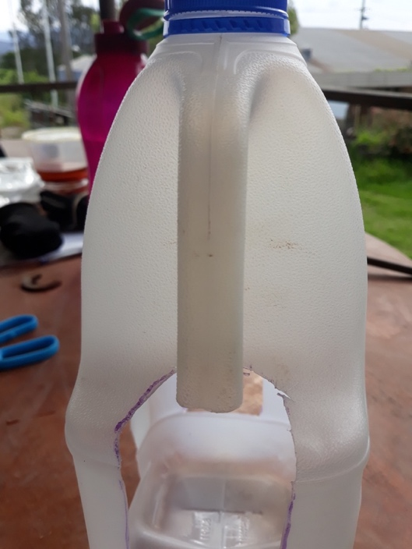

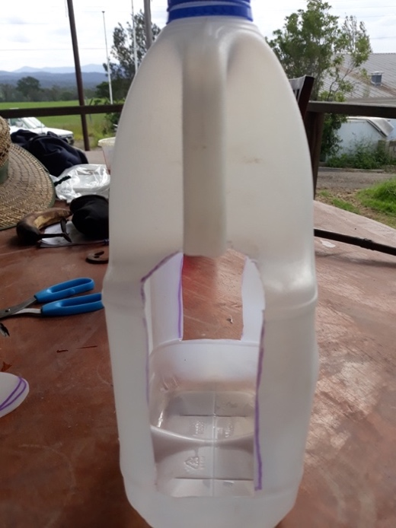
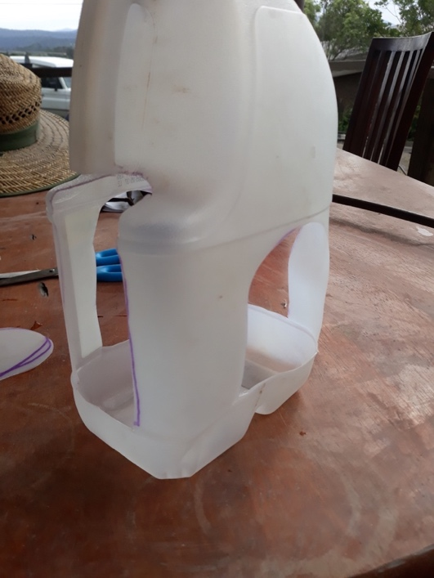

Step 3 – Ears and a tail!
Pic 9 and 10:
Use the bigger side arch bits you cut out for ears. Draw what you think are good ears. Here’s an example. Draw a tail too!
Cut the ears and tail out with scissors

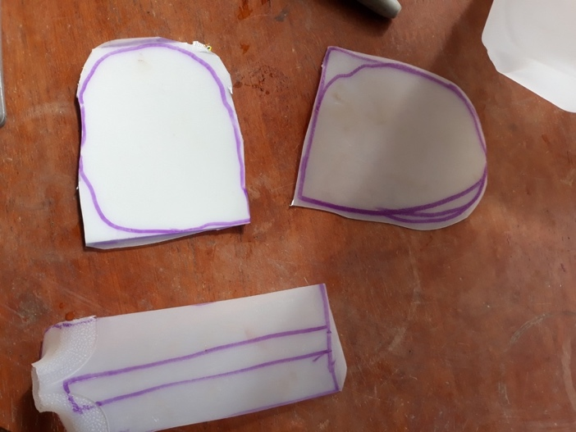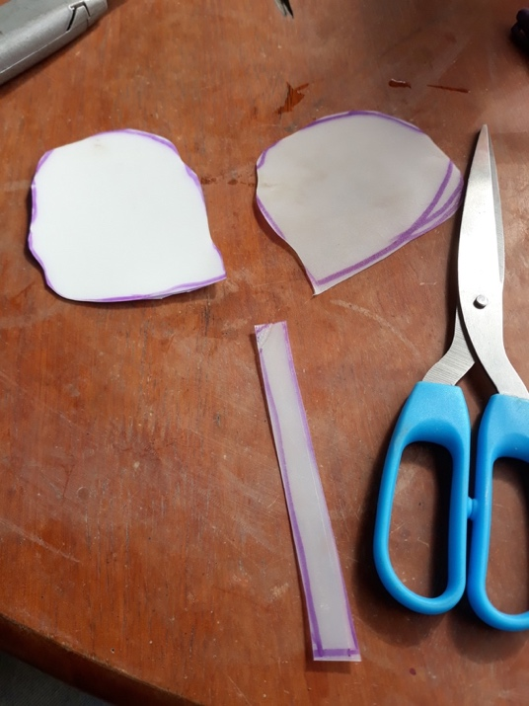

Step 4 – Hooking your ears on
Pics 11 - 13:
Draw and then cut a short slot with your Stanley-knife on an angle on both sides of your elephant's head.
Push the base of the ear into the slot and see if it goes in far enough to stay in. Do a small cut on the side of each ear and push into the ear slots and hook in. Get someone to help if you need to.

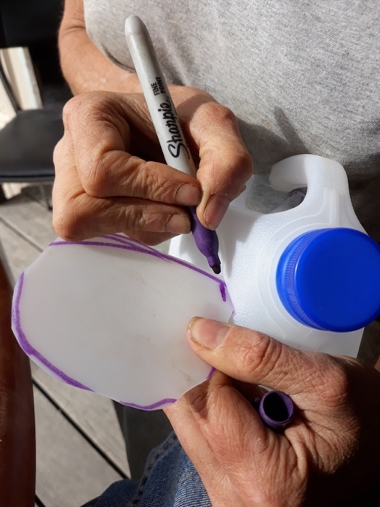
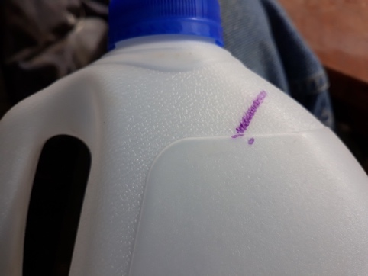
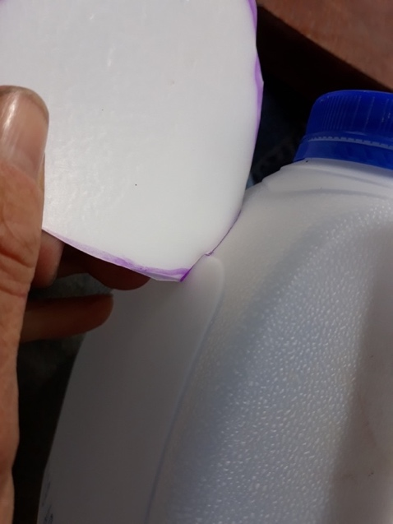

Step 5 – Hooking your tail on
Pics 14 - 16:
Make a small slot with the Stanley-knife at the back where you think your tail should go. Make a small cut in the side of the tail and hook into the slot you've just made.

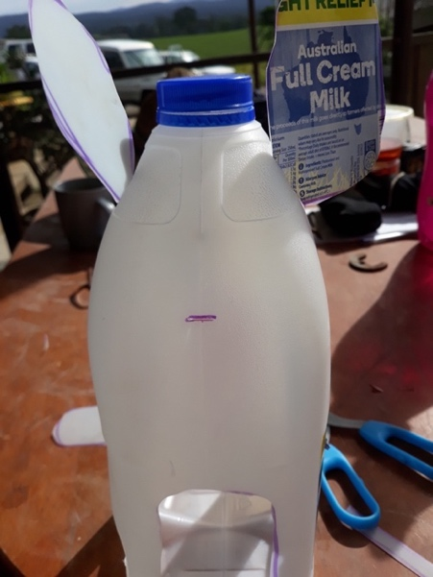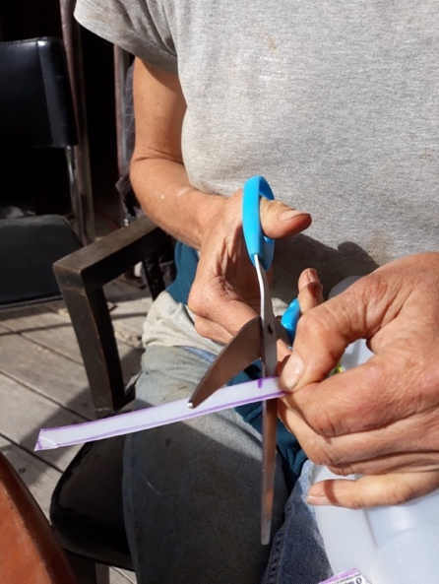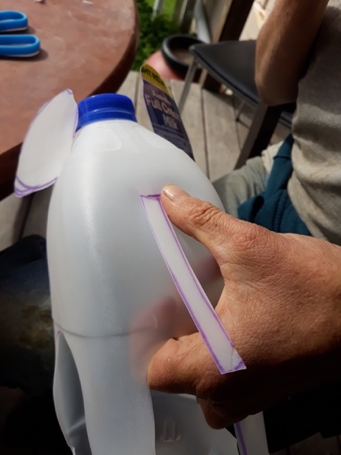

Pic 17 and 18: You're ready to decorate!
For an extra-long trunk if you want, cut the handle off another milk bottle and add on. This can be tricky, so get help.

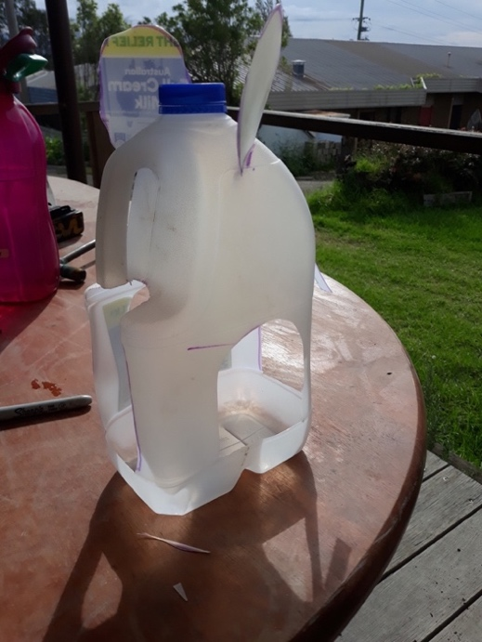
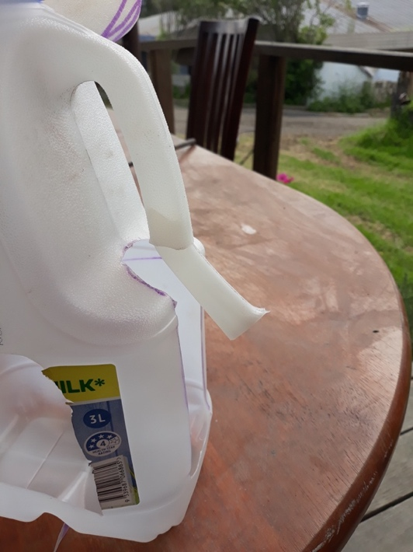

Step 5 – Decorating your elephant
Squeeze some craft glue into your plastic container. Use your paintbrush to put glue onto your paper and stick onto your elephant. Do your whole elephant so you can't see any more plastic bottle.

Pic 19:
Use two lids stuck on either way as eyes! Leave to dry.

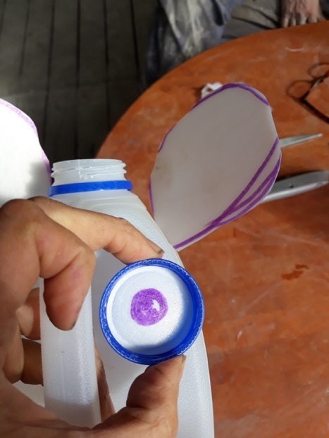

You have created a fantastic elephant!

