FABRIC BOWL
Your bowl can be used for decoration or storing things, but please do not put wet items into your bowl.

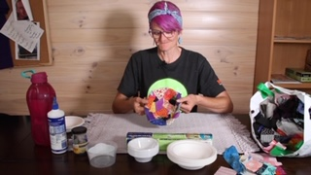

You will need:

- Something to protect your tabletop
- A bowl – plastic, paper or ceramic
- Cling wrap
- Glue – PVA works best
- Water
- A jar with a lid for mixing glue
- An old plastic container for glue
- Pieces of coloured fabric cut into small bits or small strips

Your fabric can be cut from anything lightweight.
Old linen (like a pillowcase your family does not need anymore), old clothes, or fabric scraps from sewing.
Thick fabrics do not work as well, so stick with the lightweight fabrics.

How to make your bowl:

Step 1 – Prepare your bowl
Pics 1-2:
Turn your bowl upside down.
Cover the back of your bowl with cling wrap, make sure that the whole back of the bowl is covered. Tuck the cling wrap edges under bowl edges.

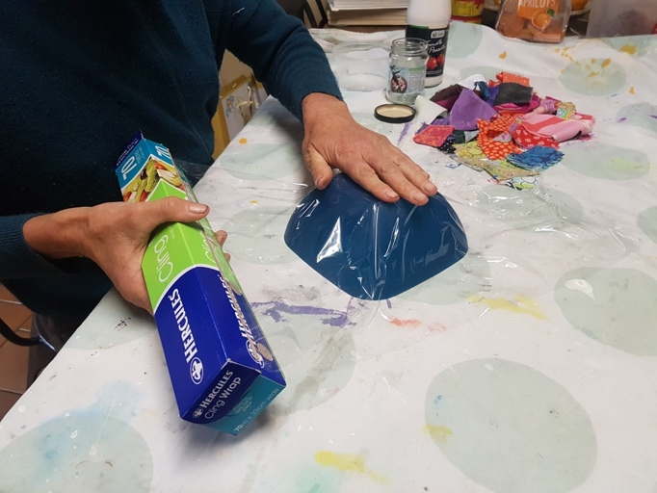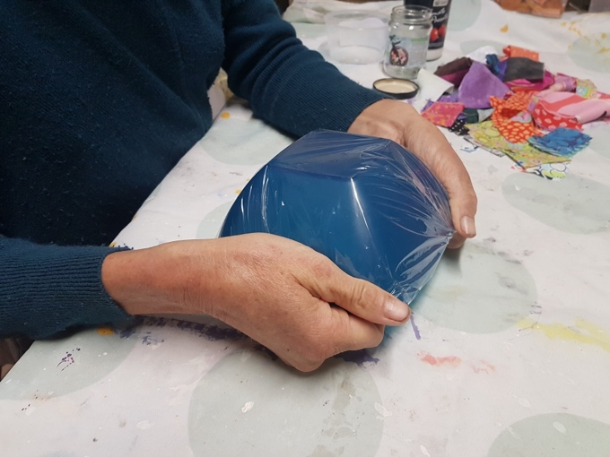

Step 2 – Prepare your glue mixture
Pics 3-4:
Make up a glue and water mixture with one third (1/3) glue and two thirds (2/3) water.
Shake the mixture well until the glue and water are blended together to make a watery glue.
Pour the mixture into your plastic glue container.

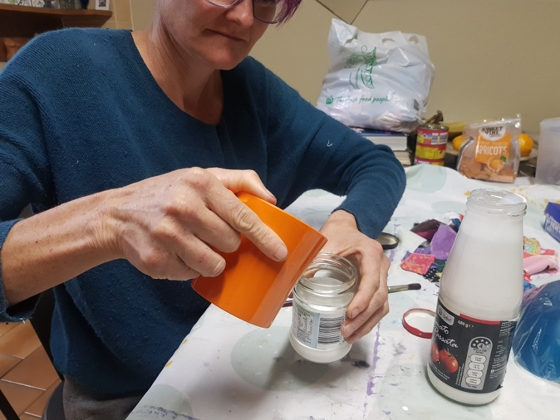
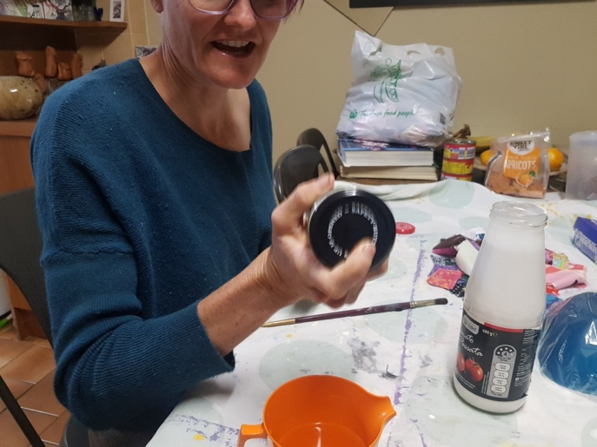

Step 3 – Decorate your bowl
Pic 5-6:
Pick up a piece of your fabric and dip it into your glue mixture, making sure it is fully covered.
Lift the fabric from glue mixture and remove excess glue that may drip.
You will need to overlap each piece of fabric; this will give your bowl strength.

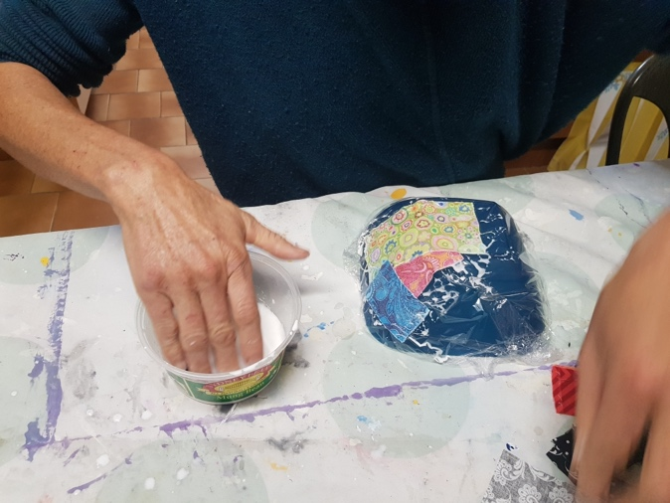
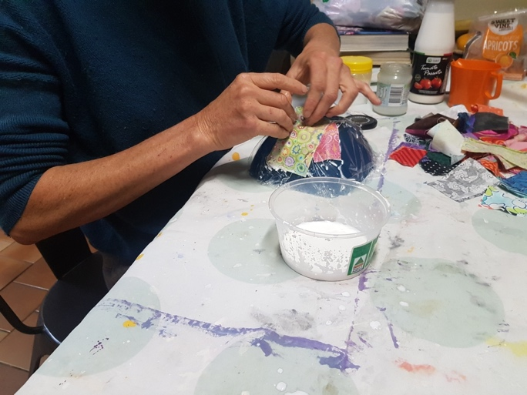

Cover the entire back of your bowl with the
fabric pieces till there is no cling wrap showing.

Step 4 –
Pic 7:
Leaving your bowl upside down, carefully put it somewhere so it can completely dry.

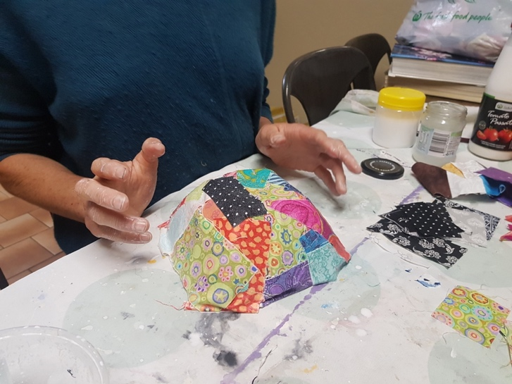

Step 5 –
When you are sure that your bowl is dry, lift your new fabric bowl off the original bowl.
Peel off the cling wrap carefully – now you have finished one beautiful bowl.

You have created completely unique bowl!

Send a pic of your finished bowl to
Jo at jo.rodie@roundsquared.net.au

